Show me…

*Project plan*



**Group E – Code Ninjas**

Nikola Chobanov

Tao Hua

Dean Farras Narendra

Coen Stange

**Version:** 2 Daniel Todorov

**Date:** 08-09-2017 Bilger Yahov

Table of Contents

**Introduction** 3

**Project statement** 4

Formal client 4

The company 5

Project leader 5

Current situation 5

Project justification 5

Research questions 6

Risks 6

Project phasing 7

Approach to reaching the end goal 7

**Mosquito** 7

Skills 7

Quality 7

Information 8

Time 8

Organization 8

Communication Plan 8

# **Introduction**

This document describes the initial planning for developing a mobile and web application called “Show me”, which will allow people to live stream video using the camera on their smartphone.

This document will serve as a contract between our development team known as Code Ninjas and our formal client – Bill Anderson. The first part of the document describes the formal client, Code Ninjas as company, who will be the project leader and the current situation at the start of this project. It also gives a justification of why the project will be of benefit for the client, what the will be the project products, what risks might arise during the development phase of the project, what will be the deliverables and non-deliverables during and at the end of the project, phases of the project and what deliverables are expected at the end of each phase.

Second part of this document gives information about the development methodology that is going to be used, what skills will be needed for executing successfully the project, quality constraints, what is the organization of the people involved in the project and how they communicate with each other.

# **Project statement**

## Formal client

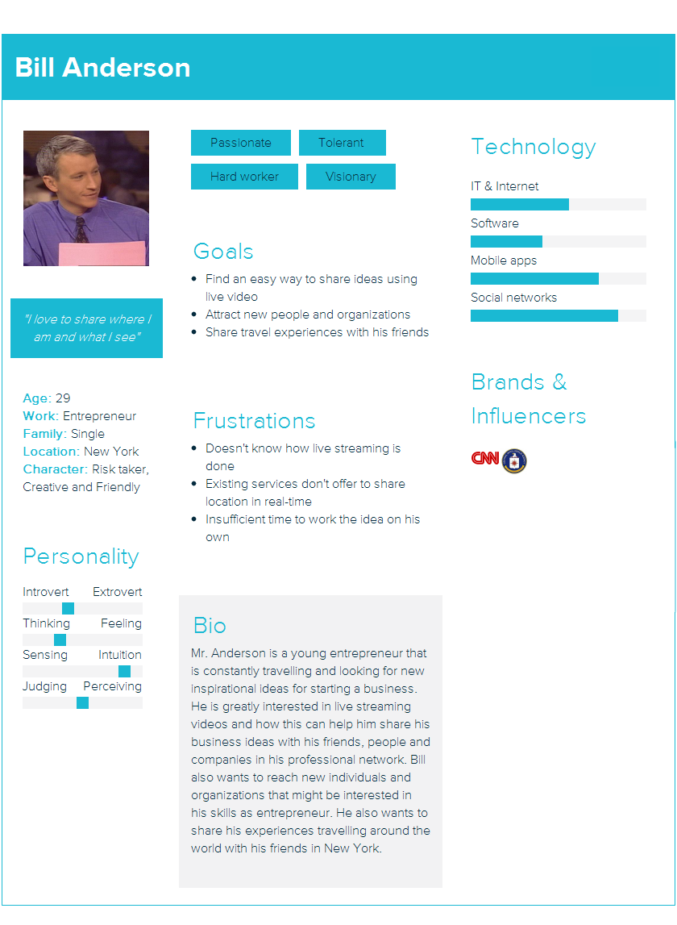

## The company

“Ninja Coders” is a company based in Eindhoven, the Netherlands. They have been building corporate software for about 15 years already. Most of their work is concentrated on entrepreneur kind of businesses, which allows them to have the “interesting” shaped mindset. Their team counts 5 people, all educated in the sphere of Software Engineering and Business studies. Undoubtedly many happy clients like to share their names, which makes it a fact, their work is always at a top level. During this project, their task is to make sure that one entrepreneur will be always ready to live-stream his ideas, right at the place where they are happening, right at the moment, when everything is going on!

## Project leader

During this project, there won’t be fixed project leader. Instead everyone from the team will play this part for a period of two weeks, during the assignment. The idea is that every member of the team can improve further his managerial skills and get to know better the responsibilities of a project leader.

Our team decided that the first to act as a project leader for the first two weeks of the project will be Bilger Yahov. He is to be followed by Dean Farras Narendra, Tao Hua, Coen Stange and Nikola Chobanov. This will be repeated until the end of the project.

## Current situation

As already mentioned Bill is a young entrepreneur, who wants his ideas to be heard. Not so common, he has that flying kind of mind, so his ideas are unfortunately always difficult to capture and visualize. Here comes the problem with him, he would need something that can make the impossible – possible. Something that can be put on drones, trains, bikes, cars, on people, animals and much more, just to be able to live stream about what is going on right there, right at that moment. He has had very interesting adventure on a camel recently, which he could not capture and turn into an idea, unfortunately. As far as his concerns reveal, this is something that he would not like to see happening again. That’s why Bill has decided on making a deal with a software company, to have such a product built for him.

Bill has tried numerous ways of capturing the moment, with mobile phones, with 360 cameras, but none of them offers exactly what he needs. Everything is fine, but none to the point that, he would say “That’s it!” Currently he is able to record the adventure, but recording the adventure loses its uniqueness, it’s interesting only when it is happening. That’s what Mr. Cooper definitely thinks. If the company, he has talked with, manages to provide him with such a product, Bill will be the happiest entrepreneur in the world.

## Project justification

Considering the frustrations that the client has been facing such as:

* Not knowing how live streaming is done
* Existing platforms and applications not offering the needed functionality
* Insufficient time to spend on ideas

Some goals have been defined. Basically, the idea that holds behind the minds of our software engineers is to build a system, which will address certain problems and will follow goals and actions. Among all the small details about the project, the most specific and direct goals might be described as:

* Finding an easy way to share ideas through live videos
* Attracting more people and organizations
* Sharing experience with surrounding people
* Saving time and money

## Research questions

Main research question: How to create a distributed video and location live streaming service?

Sub-questions:

* What is needed to create a distributed system?
* What database system fits best for this application?
* How to stream video and audio from a phone app to the server?
* How to broadcast a video and audio stream to multiple clients?
* What time interval can be used to share location?
* How to create a cross-platform phone app?
* Which parts of the phone app still need platform specific code?
* Which protocol can best be used between the phone app and the server to reduce bandwidth?
* Which protocol can best be used between the server and the web-app?
* In which language/framework should the server of the application be written?
* How can the server be hosted in the cheapest way possible?
* How to do authentication inside the phone app?
* How to do authentication inside the web app?
* Would it be interesting to share data of other sensors?
* How to handle user registration?
* What is the UI of the phone app?
* What is the UI of the web-app?
* Which map provider is best to be used within the web-app?

## Risks

|  |  |  |  |  |
| --- | --- | --- | --- | --- |
| Risk | Likeliness | Prevention | To Do After Happening | Impact |
| Lack of Knowledge | Low | Choose a Project that has Familiar Required Skills to Us | Learn the Required Skills. | Medium |
| Lack of Time | Low | Make a Detailed Time Table and Stick with it. | Negotiate with the Client to reduce the scope | High |
| Lack of Communication | Low | Create a Communication Plan. | Plan a Meeting to Get an Effective Way to Communicate. | Medium |
| Knowledge Gap Between Member | Medium | Choose a Project that has Familiar Required Skill to all Project Member | Do a Pair Programming. | Low |
| Lack of documentation on Technology | Low | Choose an Available and a Well Documented Technology to Develop the Project. | Change the Currently Used Technology. | Medium |
| Program Doesn’t Run | Low | Send a Working Application Periodically. | Use the last working version of the application | High |
| Demo at presentation fails | Low | Test a hour before the demo if everything is still working perfectly | Ask to reschedule the demo | High |

## Project phasing

Requirements document

Class diagram Mobile app

Presentation

Implement in sprints (using spiral model)

Project plan

MoSCoW list

Demo

Sequence diagrams

Create client persona

Use cases

UI for the Mobile app (wireframe)

Test plan

Test cases

UI for the Web app (wireframe)

Sprints plan

***M5***

***M4***

***M3***

***M2***

***M1***

**Deliverables for Milestone 1 (M1): (01/09/2017 - 08/09/2017)**

* Project plan
* Client persona

**Deliverables for Milestone 2 (M2): (11/09/2017 – 22/09/2017)**

* Requirements document containing list of requirements
* MoSCoW list that is included into the requirements document
* Use cases also part of the requirements document
* Test plan
* Test cases

**Deliverables for Milestone 3 (M3): (25/09/2017 – 06/10/2017)**

* Class diagram describing the classes of the mobile app
* Sequence diagrams showing how the objects communicate with each other (e.g. server and mobile app, server and web app)
* Wireframe(s) showing the initial user interface of the mobile app
* Wireframe(s) depicting the initial user interface of the web app
* Planning for the sprints

**Deliverables for Milestone 4 (M4): (09/10/2017 – 20/10/2017)**

* Implementation in sprints using the spiral model (see next section for details).
* Results of the executed test cases for each sprint in the form of a test report

**Deliverables for Milestone 5 (M5): (13/11/2017 – 19/01/2018)**

* Final presentation
* Demo of the final product
* Source code of the mobile app
* Source code of the web app

## Skills

In order to complete this project, the following skill are required:

**Technical**

* NodeJS
* ReactJS
* Xamarin
* Git

**Non-Technical**

* Project Management
* Pair Programming
* Professional Meeting

## Quality

In order to deliver a good quality end product. There are some Indicators that need to be followed. They are,

1. **Periodic Meeting with The Client**

Periodic meeting is purposed to understand the client’s needs and what can be improved from the previous implementation.

1. **On Time Delivery**

Following the Project Plan Time Table to ensure delivering product before deadline.

1. **Testing Before Delivery**

A test on the application should be conducted before the product delivery to the client. So that, the client receives a fully working application.

1. **Code Review**

By doing Code Review, it ensures the coding standard of the application.

## Development Methodology

For this project, our team is going to use the spiral model. It involves four phases – planning, risk analysis, development and evaluation phase. The planning phase consists of gathering and studying requirements, feasibility study, determining if it is possible or not, reviews and walkthroughs to integrate the requirements and produce a final list. The risk analysis stage identifies the potential risks, the degree of likeliness, how they can be avoided, how they can be mitigated in case they occur and how high the impact will be on the project. The development phase is where the software product is build and tested. The last step of the spiral model is evaluation and during this phase the client evaluates the software product and provides his feedback and approval.

Advantages of spiral model:

* Development is fast
* Risk evaluation is proper
* Control towards all the phases of development
* More and more features are added in a systematic way
* There is room for customer feedback
* Changes are implemented faster

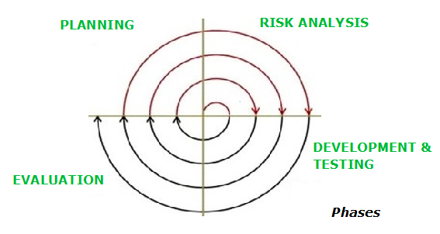

## Organization

Bill Anderson

*Formal Client*

Erik van der Schriek

*Fontys tutor*

**Code Ninjas**

Nikola Chobanov

Dean Farras Narendra

Bilger Yahov

Tao Hua

Coen Stange

## Communication Plan

|  |  |  |  |
| --- | --- | --- | --- |
| Role | Communication Purpose | Communication Type | Frequency |
| Client | 1. Updating Progress  2. Application Feedback | 1. Email  2. Meeting | Weekly |
| Mentor | 1. Document Feedback. | 1. Email  2. Meeting | Weekly |
| Within Group | 1. Planning a Meeting with Client or Mentor.  2. Helping the Others. | 1. Meeting  2. Messenger | Daily |